Task 02

1. We are going to explore this part from React Native website

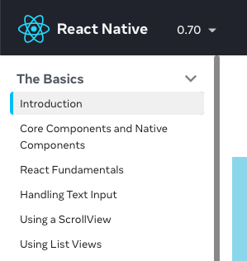

1. Create a simple app that shows some welcoming text, some image(s)
2. Create your custom components
3. Experiment using JSX to display your component
4. Demonstrate the use of props
5. Demonstrate the use of JSX, props, and state
6. Create a text input, and turn every input into a list view.
7. **Create a report by providing the screenshots of all the tasks you have followed from 1 until 7 and submit in iTaleem. Only one group member submit the report in iTaleem.**
8. **Write only group members who attended and participated for today’s class.**